1. 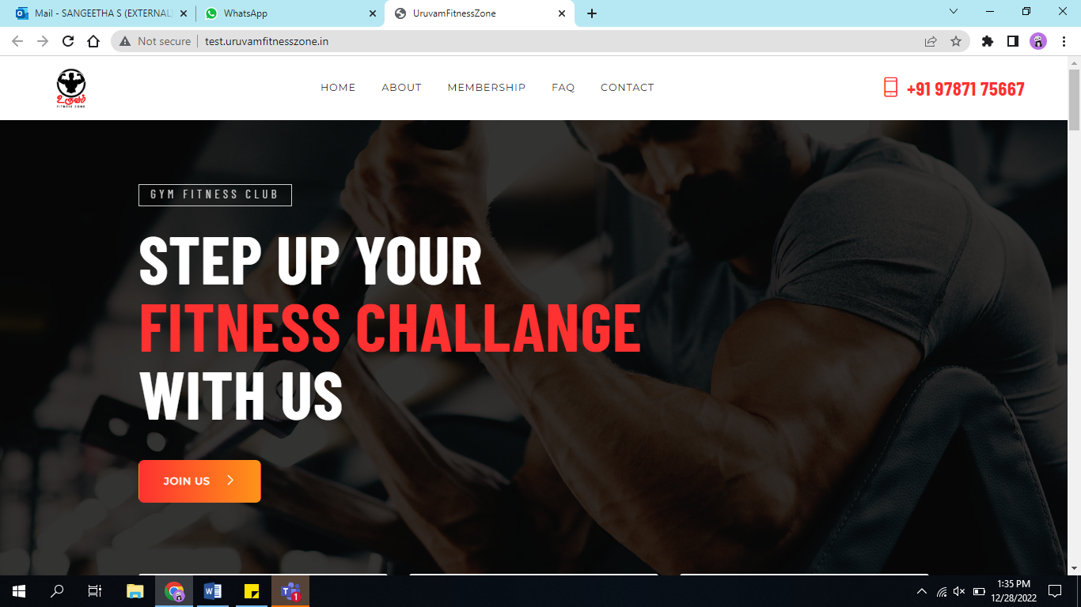

**Background image konjo 4 or 5 images add panni automatic ah konja nerathuku oruka mara mari vachukalam?(not recommended)**

1. 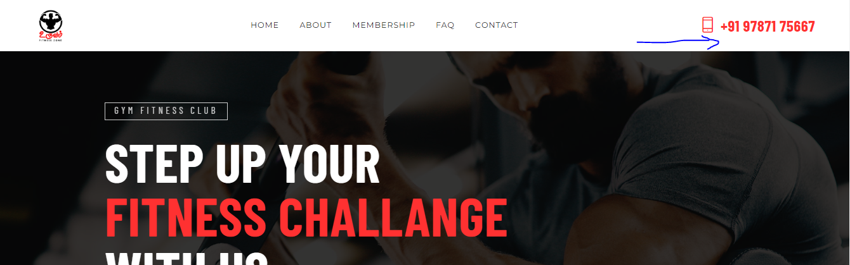

**Below phone we can add logos of insta, fb,twitter, etc which bro will provide the profile link that can be mapped(not looks good)**

1. 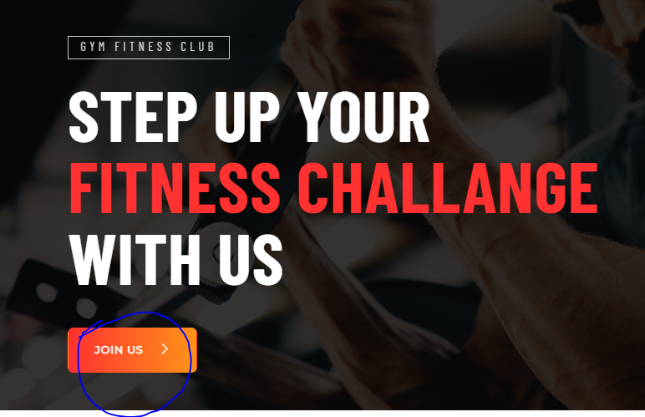

**Join us-> direct whatsapp ping-> 9789145667 (change to this number in all places)(Done)**

1. 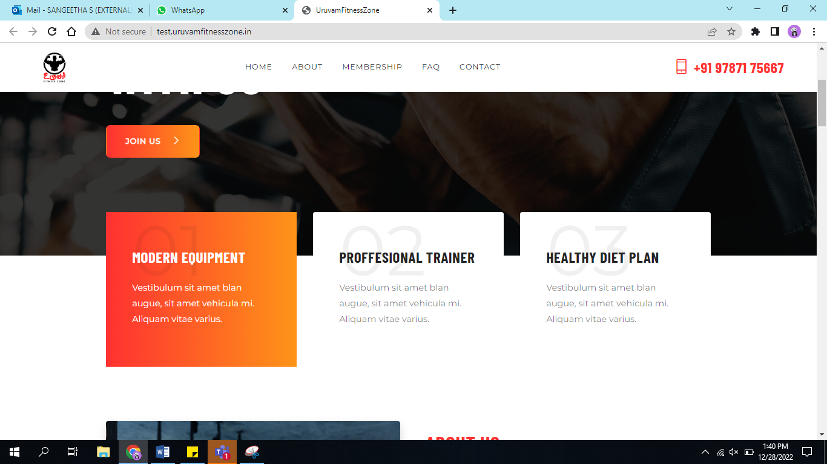

**For these 3 top things whatever we have is fine-> Instead of Healthy Diet plan please change it to “Science Based Diet & Workout Plan”(Done)**

* **Description add yourself**

1. 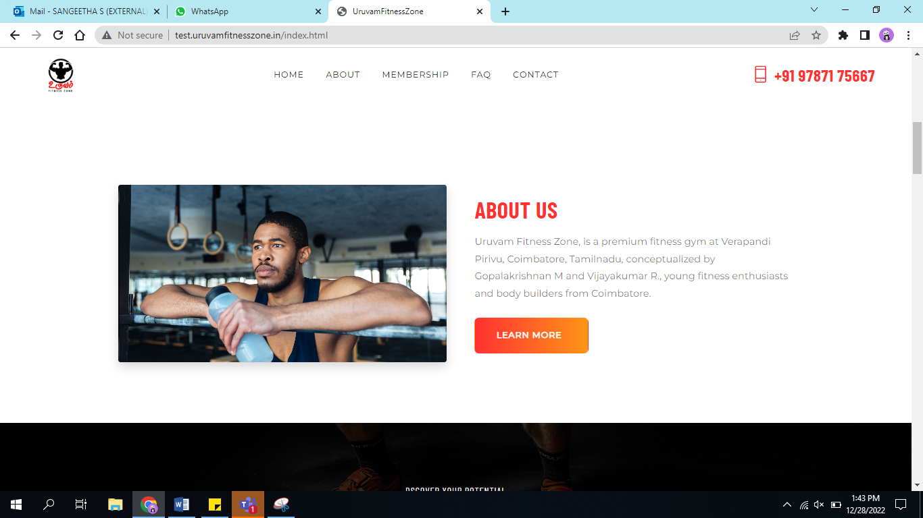

**About us- please make the images to be dynamic..(Done) not much just few images of owners transformation..(Images needed) bro will provide..description he told he will give little more(Description needed)**

1. 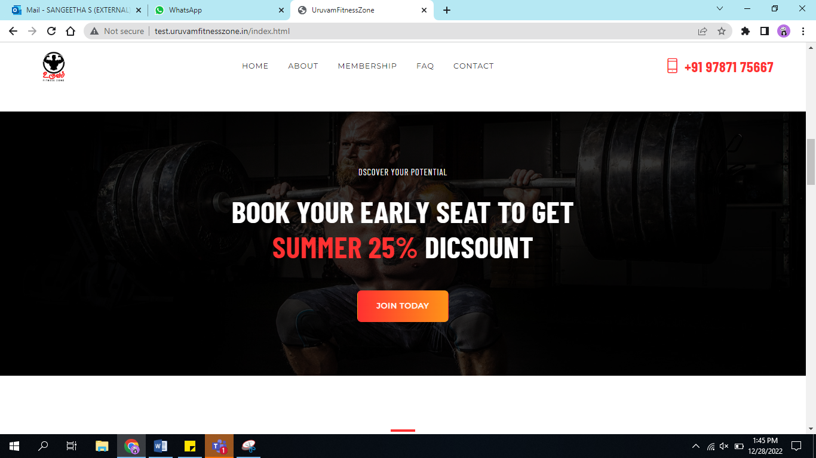

**For this section he will provide us the offers, and the bottom of the section he told us to add T & C applied since it might differ and it might keep changing.**

* **Join Today- > this should again route us to whatsapp(9789145667) with offer description(for example “Womens day offer-enquiry”)(Done)**

1. 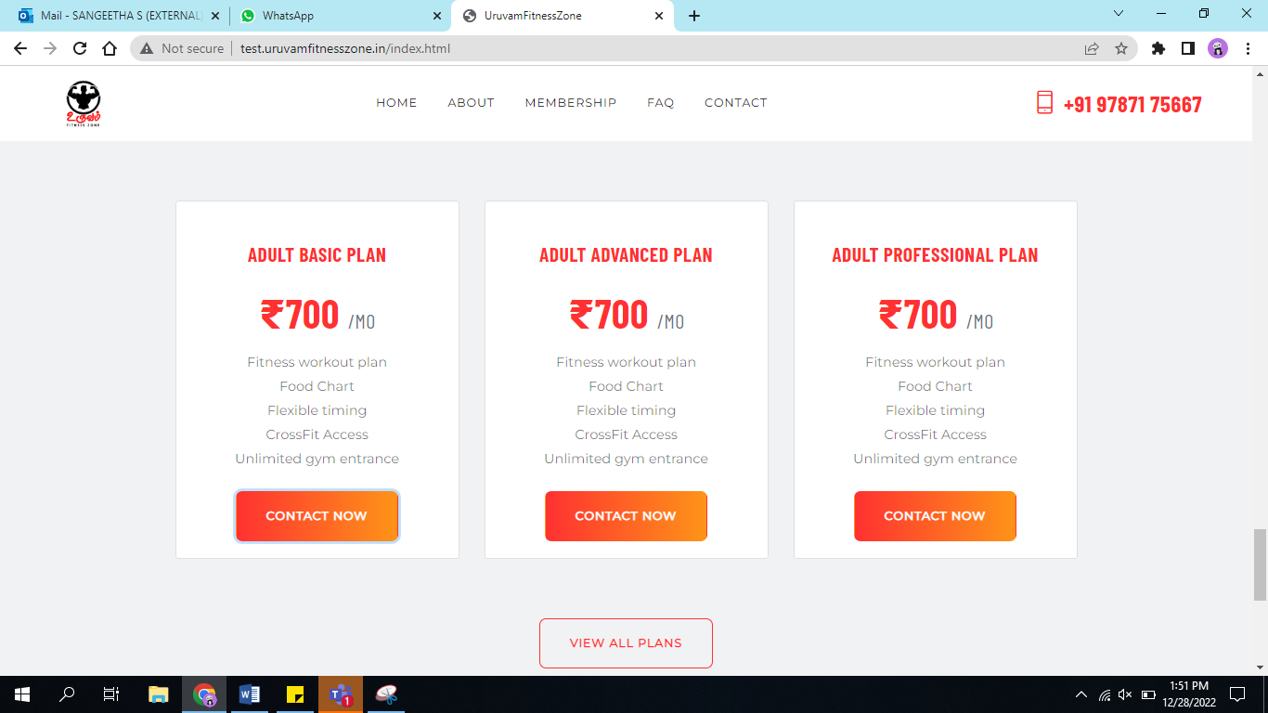

**Similarly when they want to choose ADULT BASIC PLAN -> Contact now-> it should directly route to whatsapp (9789145667)with the package description (Eg: Adult Basic Plan- Enquiry)(Content needed)**

* **Onclick of view plans it will routed to membership page ??(Done)**

1. 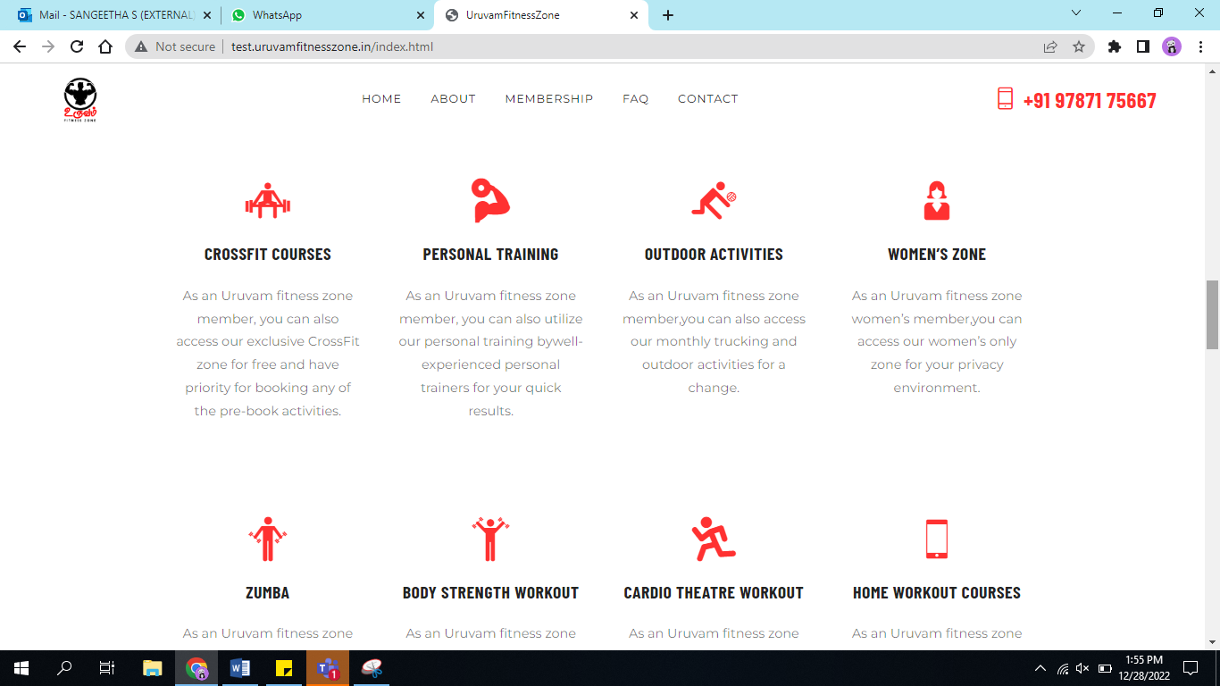

**Courses are good , he wants to add 4 more he will provide us..(Not recommended)**

1. 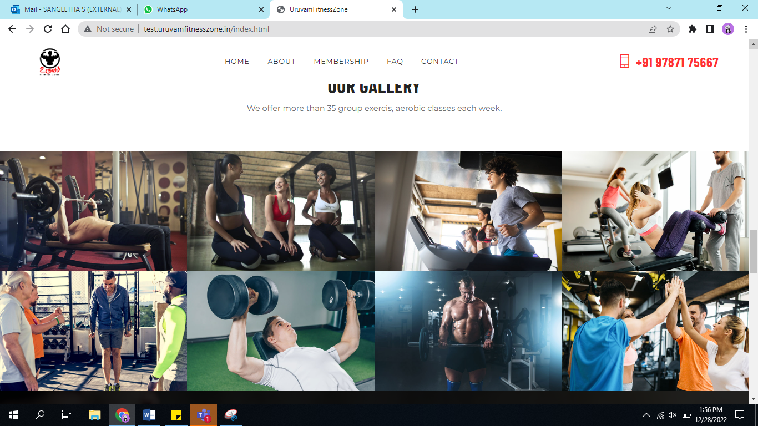

**Gallery-> Existing view is fine,, we have 8 images right.. can we add flip image..like behind 1 image we can have 10 photos and flip between the images for specific time.(Done – Added totally 16 images)**

1. 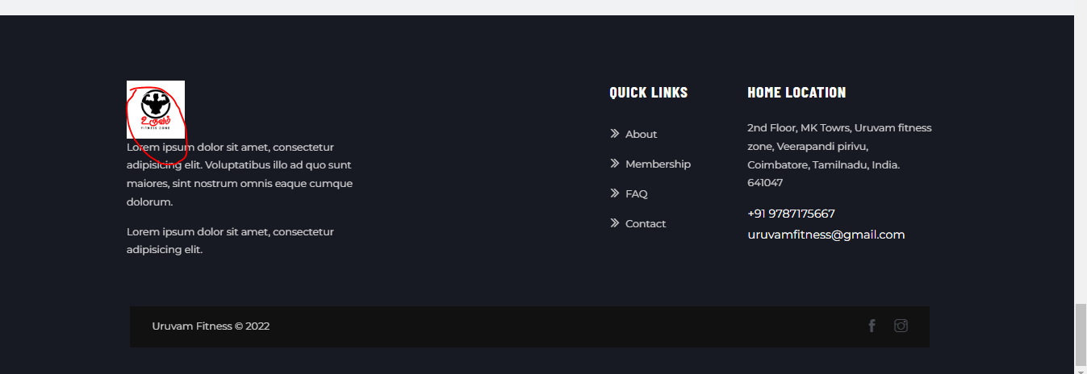

**Wanted logo without white backgrounds itseems – and content add it yourself..(Done)**

1. **Client list-> we can add it in Quick links above About menu-> he will give us the list(no need to segregate based on male or female)(inputs needed)**
2. **Trainer list-> on top we will remove the contact menu instead we can add Trainer menu and on click we can show the trainers list with their background.(inputs needed)**
3. **Tutorial link-> this will be routed to our Youtube link where separate playlist link will be created and he will provide us.(inputs needed)**
4. **Success stories -> this also going to be a video and youtube link will be provided.(yet to be discuss)**
5. 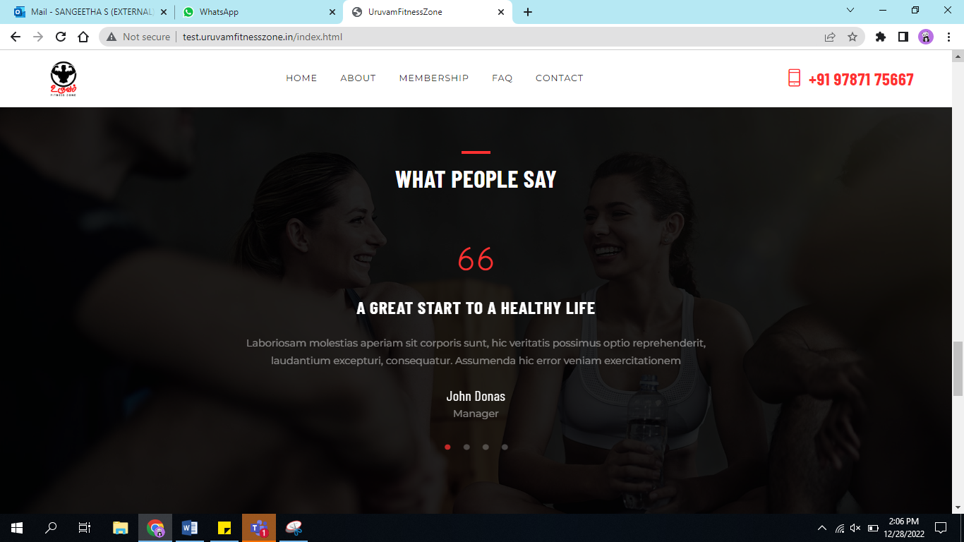

**Testimonials -> this is fine ..we will add some top 5 to 10 testmonials in this page.. similarly the feedback will be updated with the client name and if he is a doctor that profession also will be mentioned below similar to dummy page.. below we can add view more button and from there it can take us to one page where all feed backs can be displayed..(Done)**

* **And on the 66 quotation which is showing instead we can have small image where it will show the client image.. you can refer to our insta page for the recent testimonial..similar to that we can add an image.(Done)**

1. 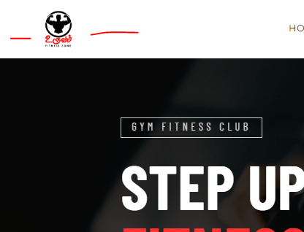

**On the top near the logo we can google location (not recommended)**